CCNA - MODULE 4: ROUTING AND SWITCHING
ASSESSMENT M4-A1 - COMPLETE ANSWERS

Name : HET SIDDHPURIYA
Date : 07-10-2026

Recommended Packet Tracer Addressing Plan

Device / Interface | VLAN | IP Address | Subnet Mask | Default Gateway
PC1 - Management / Marketing | 10 | 192.168.10.10 | 255.255.255.0 | 192.168.10.1
PC2 - Staff / Engineering | 20 | 192.168.20.10 | 255.255.255.0 | 192.168.20.1
Router G0/0.10 | 10 | 192.168.10.1 | 255.255.255.0 | -
Router G0/0.20 | 20 | 192.168.20.1 | 255.255.255.0 | -

Important: If your router uses GigabitEthernet0/0/0 instead of GigabitEthernet0/0, replace G0/0 with G0/0/0 in the commands.

SECTION A - CONCEPT APPLICATION

S1. Static Routing vs Dynamic Routing

- Static routing means the network administrator manually configures routes on the router. The router does not automatically learn routes from neighboring routers. Dynamic routing uses routing protocols such as RIP or OSPF to automatically exchange routing information and learn reachable networks.

Static Routing | Dynamic Routing
Routes are configured manually. | Routes are learned automatically.
Uses very little CPU, memory, and bandwidth. | Uses CPU, memory, and bandwidth for routing updates.
Network changes must be updated manually. | Can automatically adapt to topology changes.
Simple and predictable for small networks. | Better for medium and large networks.
No routing protocol traffic. | Routing protocols exchange route information.

Why static routing is the best choice in this scenario:
- The startup has only two routers, so there are very few routes to maintain.
- The topology rarely changes, so automatic route recalculation is not necessary.
- Static routing is simple to configure and troubleshoot.
- It avoids routing protocol update traffic and uses fewer router resources.
- For a small and stable network, static routes are more efficient than implementing a dynamic routing protocol.
Example static route:
ip route 192.168.20.0 255.255.255.0 10.0.0.2

S2. RIP vs OSPF

Feature | RIP | OSPF
Routing type | Distance Vector | Link State
Metric | Hop count | Cost
Maximum hop count | 15 usable hops | No 15-hop limitation
Convergence | Slower | Faster
Scalability | Small networks | Medium and large networks
Algorithm | Bellman-Ford | Dijkstra Shortest Path First
Administrative Distance | 120 | 110

Recommended protocol: OSPF
- OSPF converges faster when a link or route changes.
- OSPF scales much better as more branch routers are added.
- RIP is limited by a maximum hop count of 15 and is better suited to very small networks.
- OSPF calculates efficient paths using link-state information and the Shortest Path First algorithm.
- Therefore, OSPF is the better long-term choice for a growing five-branch network.

S3. MAC Address Table and Frame Forwarding

- A switch learns MAC addresses dynamically by examining the source MAC address of every frame that enters a switch port. It stores the source MAC address together with the incoming port in its MAC address table.

1. PC1 sends a frame into the switch through Fa0/1.
2. The switch reads PC1's source MAC address and learns that this MAC address is reachable through Fa0/1.
3. If the destination MAC address is not yet in the MAC table, the switch treats it as an unknown unicast and floods the frame out all other ports in the same VLAN except the incoming port.
4. PC2 receives the frame and sends a reply through Fa0/2.
5. The switch learns PC2's source MAC address on Fa0/2.
6. After both addresses are learned, future frames are forwarded only to the correct destination port instead of being flooded.

Learned Device | Switch Port
PC1 MAC Address | Fa0/1
PC2 MAC Address | Fa0/2

- Simple rule: Learn the source MAC address, check the destination MAC address, and then either forward directly or flood if the destination is unknown.

S4. VLAN Segmentation and 802.1Q Trunking

- A VLAN, or Virtual Local Area Network, logically separates devices into different broadcast domains even when the devices are connected to the same physical switch. For example, Marketing devices can be placed in VLAN 10 and Engineering devices in VLAN 20.

Main benefits of VLAN segmentation:
- Improves security by separating departments.
- Reduces unnecessary broadcast traffic.
- Improves network organization and management.
- Allows logical grouping of users independently of their physical location.
- Improves performance by limiting broadcast domains.
An 802.1Q trunk carries traffic for multiple VLANs over one physical link. The switch adds an 802.1Q VLAN tag to frames on the trunk so the receiving router or switch can identify the VLAN to which each frame belongs. This allows VLAN 10 and VLAN 20 traffic to share the same switch-to-router connection without mixing the two logical networks.

S5. Inter-VLAN Routing and Router-on-a-Stick

- Devices in different VLANs are in different Layer 3 networks and cannot communicate directly through a Layer 2 switch. Inter-VLAN routing is therefore required to route packets between VLAN 10 and VLAN 20.

- Router-on-a-Stick uses one physical router interface and creates a separate logical sub-interface for each VLAN. Each sub-interface is configured with an 802.1Q VLAN ID and an IP address that acts as the default gateway for that VLAN.

G0/0
G0/0.10 -> VLAN 10 -> 192.168.10.1/24
G0/0.20 -> VLAN 20 -> 192.168.20.1/24

Advantages of Router-on-a-Stick over using a separate physical router interface for every VLAN:
- Uses only one physical router interface.
- Requires less cabling and fewer physical ports.
- Is cost-effective for a small startup network.
- Can support multiple VLANs by adding logical sub-interfaces.
- Is easier to expand than dedicating one physical interface to each VLAN.

S6. Wireless Security and MAC Filtering

- Wireless security should use strong authentication and encryption. Open networks and WEP are insecure and should not be used. WPA2 or WPA3 should be used where supported, and WPA2/WPA3 Enterprise is preferred when the organization has centralized authentication infrastructure.

Option | Use / Security Level
Open Wi-Fi | No authentication; not recommended.
WEP | Obsolete and weak; not recommended.
WPA / WPA2 Personal | Uses a shared password; suitable for small offices.
WPA3 | Stronger modern wireless protection where supported.
WPA2/WPA3 Enterprise | Uses individual employee credentials; best for controlled business access.
MAC Filtering | Allows or blocks devices by MAC address; useful only as an additional control.

- Recommended approach: Use WPA2/WPA3 Enterprise authentication where available so each employee receives individual credentials. This provides strong access control while still making onboarding manageable. MAC filtering can be added as a secondary control, but it should not be the main security method because MAC addresses can be spoofed. For a very small office without enterprise authentication, use WPA2/WPA3 Personal with a strong password and optional MAC filtering.

SECTION B - PRACTICAL CONFIGURATION TASKS

Recommended Packet Tracer Topology

PC1 Fa0 -------- Switch Fa0/1
PC2 Fa0 -------- Switch Fa0/6
Switch Fa0/24 -- Router G0/0

- Use one Cisco 2960 switch, one Cisco router such as a 1941 or 2911, and two PCs. Use Copper Straight-Through cables for the end-device and router connections.

Task 1. Configure Management and Staff VLANs

- Requirement: Create VLAN 10 named Management and VLAN 20 named Staff, assign access ports, and verify the configuration.

- Switch configuration:
enable
configure terminal
vlan 10
name Management
exit
vlan 20
name Staff
exit
interface range fa0/1-5
switchport mode access
switchport access vlan 10
exit
interface range fa0/6-10
switchport mode access
switchport access vlan 20
exit
end
copy running-config startup-config

- Verification command:
show vlan brief

- Expected result: VLAN 10 should display the Management access ports and VLAN 20 should display the Staff access ports. Take a screenshot of the output for submission.

Task 2. Configure an 802.1Q Trunk Link

- Assume switch interface Fa0/24 connects to router interface G0/0.

enable
configure terminal
interface fa0/24
switchport mode trunk
switchport trunk allowed vlan 10,20
no shutdown
exit
end
copy running-config startup-config

- Verification commands:
show interfaces trunk
show interface fa0/24 switchport

- Fa0/24 should show trunking status.
- Allowed VLANs should include only VLAN 10 and VLAN 20.
- Keep the native VLAN consistent on both ends. For this basic topology, leave the default native VLAN unchanged.

Task 3. Configure Router-on-a-Stick for Inter-VLAN Routing
- Router configuration:
enable
configure terminal
interface g0/0
no shutdown
exit
interface g0/0.10
encapsulation dot1Q 10
ip address 192.168.10.1 255.255.255.0
exit
interface g0/0.20
encapsulation dot1Q 20
ip address 192.168.20.1 255.255.255.0
exit
end
copy running-config startup-config

- PC1 IP configuration:
Setting | Value
IP Address | 192.168.10.10
Subnet Mask | 255.255.255.0
Default Gateway | 192.168.10.1

- PC2 IP configuration:
Setting | Value
IP Address | 192.168.20.10
Subnet Mask | 255.255.255.0
Default Gateway | 192.168.20.1

- Router verification:
show ip interface brief

- The parent interface and both sub-interfaces should be up/up. Then perform the following tests:
PC1> ping 192.168.10.1
PC2> ping 192.168.20.1
PC1> ping 192.168.20.10

- A successful final ping from PC1 to PC2 confirms that inter-VLAN routing is working. Capture a screenshot of the successful ping.

Task 4. Capture and Analyze Inter-VLAN Traffic

- Generate ICMP traffic from the VLAN 10 host to the VLAN 20 host using:
ping 192.168.20.10

- Useful Wireshark display filters:
icmp
vlan && icmp

- Traffic flow:
PC1 (192.168.10.10 / VLAN 10)
|
Switch
|
802.1Q Trunk
|
Router
|
802.1Q Trunk
|
Switch
|
PC2 (192.168.20.10 / VLAN 20)

Frame analysis:
1. PC1 creates an IP packet with source IP 192.168.10.10 and destination IP 192.168.20.10.
2. Because the destination is on another subnet, PC1 sends the Ethernet frame to its default gateway. The destination MAC address is therefore the router MAC address, not PC2's MAC address.
3. When the frame crosses the switch-to-router trunk, it carries an 802.1Q tag for VLAN 10.
4. The router removes the incoming Layer 2 header, examines the destination IP address, selects VLAN 20, and creates a new Ethernet frame.
5. The outgoing frame uses the router interface MAC address as the source MAC and PC2's MAC address as the destination MAC. On the trunk, the frame is tagged for VLAN 20.
6. The switch removes the VLAN tag before forwarding the frame out PC2's access port.
Location | Source IP | Destination IP | Source MAC | Destination MAC | VLAN
PC1 -> Switch | 192.168.10.10 | 192.168.20.10 | PC1 MAC | Router MAC | 10
Switch -> Router | 192.168.10.10 | 192.168.20.10 | PC1 MAC | Router MAC | 10 tagged
Router -> Switch | 192.168.10.10 | 192.168.20.10 | Router MAC | PC2 MAC | 20 tagged
Switch -> PC2 | 192.168.10.10 | 192.168.20.10 | Router MAC | PC2 MAC | 20

- Note: Replace PC1 MAC, Router MAC, and PC2 MAC with the actual addresses observed in your Packet Tracer or Wireshark capture.
Explanation for the written report: The source and destination IP addresses remain the same from the original sender to the final destination. The Ethernet source and destination MAC addresses change when the packet crosses the router because the router removes the incoming Layer 2 frame and creates a new Layer 2 frame for the destination network. The 802.1Q tag on the trunk identifies whether the frame belongs to VLAN 10 or VLAN 20.

SECTION C - MINI CAPSTONE PROJECT

TechLaunch Startup Network Build and Fault Diagnosis
- Objective: Build a two-VLAN network for Marketing and Engineering, configure an 802.1Q trunk and Router-on-a-Stick, then diagnose a failure where Marketing can communicate within its own VLAN but cannot reach the Engineering file server.

Network Plan
Department | VLAN | Network | Gateway | Example Host
Marketing | 10 | 192.168.10.0/24 | 192.168.10.1 | 192.168.10.10
Engineering | 20 | 192.168.20.0/24 | 192.168.20.1 | 192.168.20.10

Switch Configuration
enable
configure terminal
vlan 10
name Marketing
exit
vlan 20
name Engineering
exit
interface range fa0/1-5
switchport mode access
switchport access vlan 10
exit
interface range fa0/6-10
switchport mode access
switchport access vlan 20
exit
interface fa0/24
switchport mode trunk
switchport trunk allowed vlan 10,20
no shutdown
exit
end
copy running-config startup-config

Router Configuration
enable
configure terminal
interface g0/0
no shutdown
exit
interface g0/0.10
encapsulation dot1Q 10
ip address 192.168.10.1 255.255.255.0
exit
interface g0/0.20
encapsulation dot1Q 20
ip address 192.168.20.1 255.255.255.0
exit
end
copy running-config startup-config

Ping-Based Fault Isolation Process
1. From the Marketing host, ping another device in VLAN 10. If it succeeds, basic local VLAN switching is working.
2. Ping the Marketing default gateway 192.168.10.1. If this fails, check the access VLAN, trunk, or router parent interface.
3. Ping the Engineering gateway 192.168.20.1. If the Marketing gateway works but this fails, inspect Router-on-a-Stick configuration and VLAN tagging.
4. Ping the Engineering file server 192.168.20.10. If both gateways work but the server does not respond, check the server IP settings, gateway, access port VLAN, and local host connectivity.
5. Use the verification commands below to determine whether the fault is Layer 2 or Layer 3.

- Layer 2 verification commands on the switch:
show vlan brief
show interfaces trunk
show interface fa0/24 switchport
show mac address-table

Layer 3 verification commands on the router:
show ip interface brief
show ip route
show running-config interface g0/0
show running-config interface g0/0.10
show running-config interface g0/0.20

Example Root Cause and Fix
Root cause: The physical router interface G0/0 is administratively down because the no shutdown command is missing. Since Router-on-a-Stick sub-interfaces depend on the parent physical interface, inter-VLAN routing fails even though hosts can still communicate inside their own VLANs.

- Verification before the fix:
show ip interface brief

The parent interface may appear as administratively down/down.
- Fix:
enable
configure terminal
interface g0/0
no shutdown
end

- Verify the repair:
show ip interface brief
ping 192.168.20.10

Short Written Capstone Report

- The network was configured with VLAN 10 for Marketing and VLAN 20 for Engineering. The switch access ports were assigned to the correct VLANs, and Fa0/24 was configured as an 802.1Q trunk carrying VLANs 10 and 20. Router-on-a-Stick was configured using sub-interfaces G0/0.10 and G0/0.20. During troubleshooting, same-VLAN communication worked, but inter-VLAN communication failed. The command show ip interface brief showed that the router's physical G0/0 interface was administratively down. The root cause was a missing no shutdown command.

Exact CLI Verification Commands Used
show vlan brief
show interfaces trunk
show interface fa0/24 switchport
show mac address-table
show ip interface brief
show ip route
show running-config interface g0/0
show running-config interface g0/0.10
show running-config interface g0/0.20
ping 192.168.10.1
ping 192.168.20.1
ping 192.168.20.10

SECTION D - AI-AUGMENTED LEARNING

Step 1. Exact Prompt Given to the AI Tool

Create a Cisco Packet Tracer configuration for a startup network.
Requirements:
1. Configure VLAN 10 named Marketing.
2. Configure VLAN 20 named Engineering.
3. Assign switch ports Fa0/1-Fa0/5 to VLAN 10.
4. Assign switch ports Fa0/6-Fa0/10 to VLAN 20.
5. Configure Fa0/24 as an 802.1Q trunk connected to a router.
6. Allow only VLAN 10 and VLAN 20 on the trunk.
7. Configure Router-on-a-Stick using router interface G0/0.
8. Configure G0/0.10 for VLAN 10 with IP address 192.168.10.1/24.
9. Configure G0/0.20 for VLAN 20 with IP address 192.168.20.1/24.
10. Allow hosts in VLAN 10 and VLAN 20 to communicate with each other.
11. Provide Cisco IOS commands and verification commands.

Step 2. AI Original Configuration Script
- Original switch configuration:
enable
configure terminal
vlan 10
name Marketing
exit
vlan 20
name Engineering
exit
interface range fa0/1-5
switchport mode access
switchport access vlan 10
exit
interface range fa0/6-10
switchport mode access
switchport access vlan 20
exit
interface fa0/24
switchport mode trunk
switchport trunk allowed vlan 10,20
no shutdown
exit
end

- Original router configuration generated by the AI:
enable
configure terminal
interface g0/0.10
encapsulation dot1Q 10
ip address 192.168.10.1 255.255.255.0
exit
interface g0/0.20
encapsulation dot1Q 20
ip address 192.168.20.1 255.255.255.0
exit
end

Bug Found Without AI
- The AI-generated router configuration did not enable the parent physical interface G0/0. The missing commands are:
interface g0/0
no shutdown

- If the parent interface remains administratively down, its sub-interfaces cannot pass traffic. This causes inter-VLAN communication to fail.
Corrected Configuration
enable
configure terminal
interface g0/0
no shutdown
exit
interface g0/0.10
encapsulation dot1Q 10
ip address 192.168.10.1 255.255.255.0
exit
interface g0/0.20
encapsulation dot1Q 20
ip address 192.168.20.1 255.255.255.0
exit
end
copy running-config startup-config

- Verification:
show ip interface brief
show vlan brief
show interfaces trunk
ping 192.168.20.10

Required 3-4 Line Debugging Note
The AI-generated configuration correctly created the VLANs, trunk, and router sub-interfaces, but it did not enable the router's physical G0/0 interface. Because the parent interface was administratively down, G0/0.10 and G0/0.20 could not pass traffic. I added the no shutdown command under G0/0. After this correction, inter-VLAN ping communication worked successfully.

FINAL SCREENSHOTS CHECKLIST

- VLAN CONFIGURATION
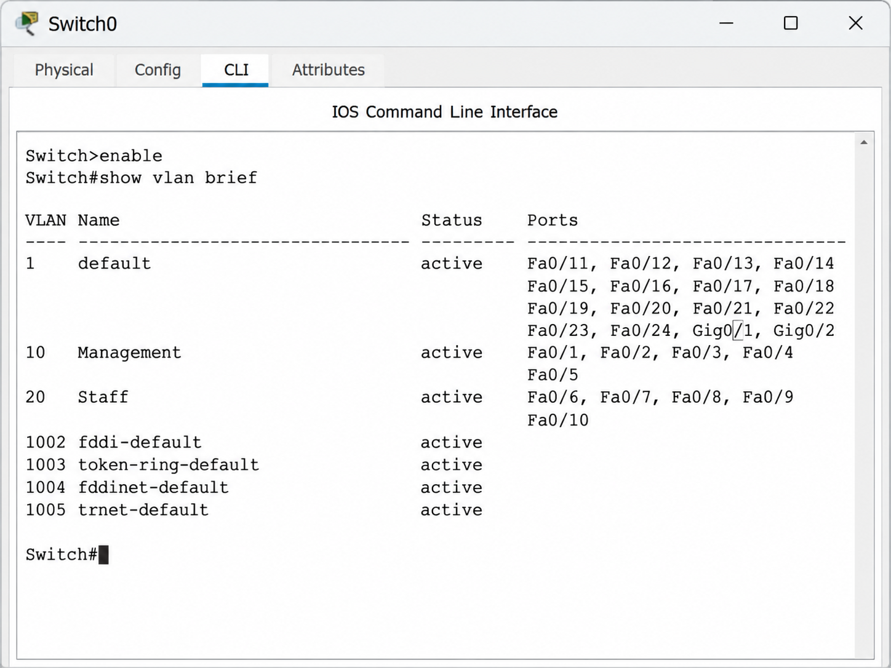

- CLI INTERFACE STATUS
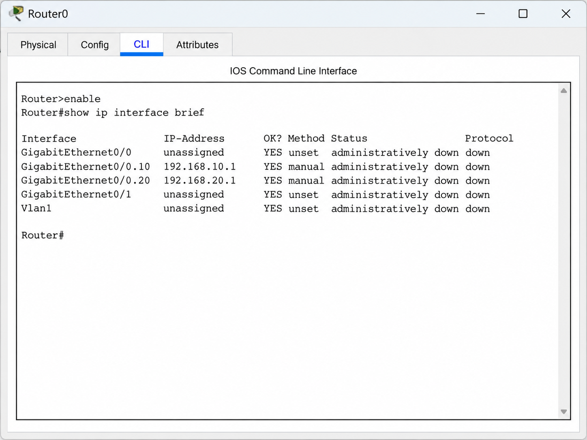
- ICMP PACKET CAPTURE
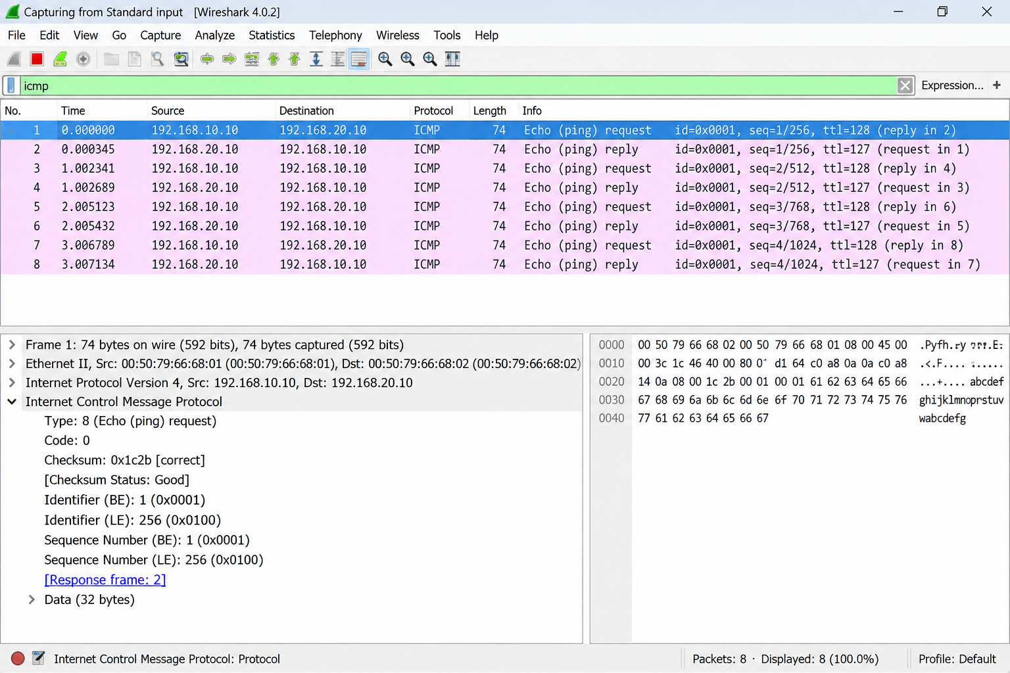

- PING RESULT
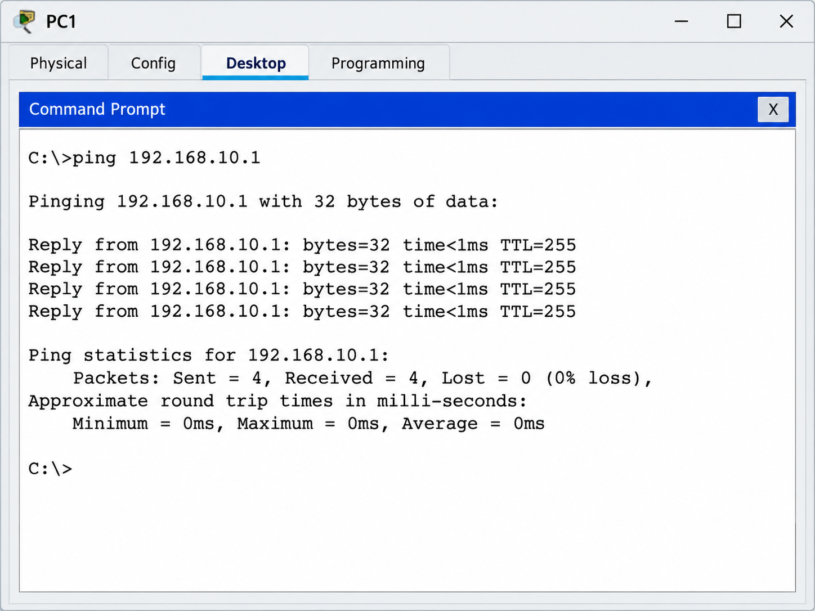

- IOS COMMANDS
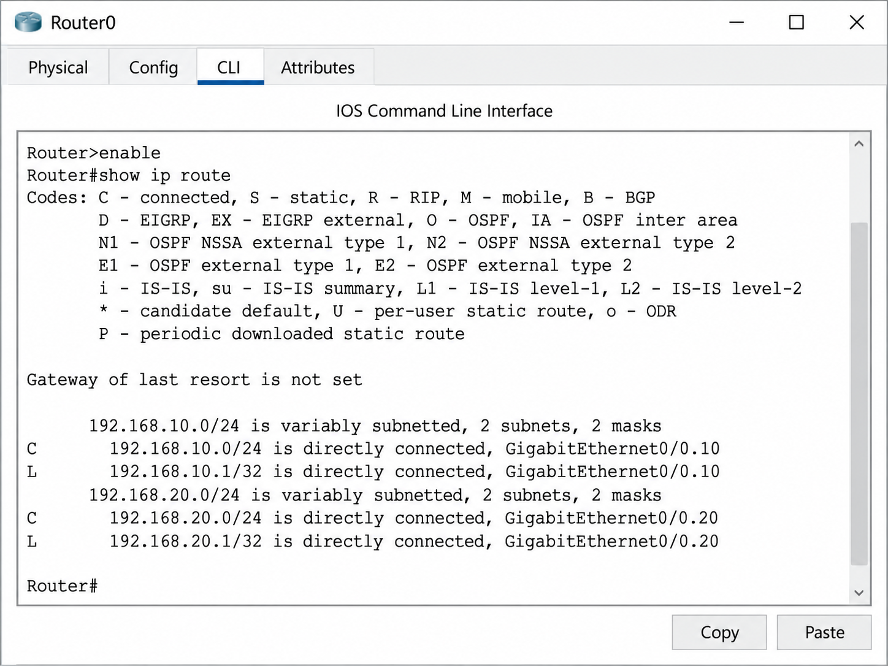

- CLI INTERFACE COMMANDS
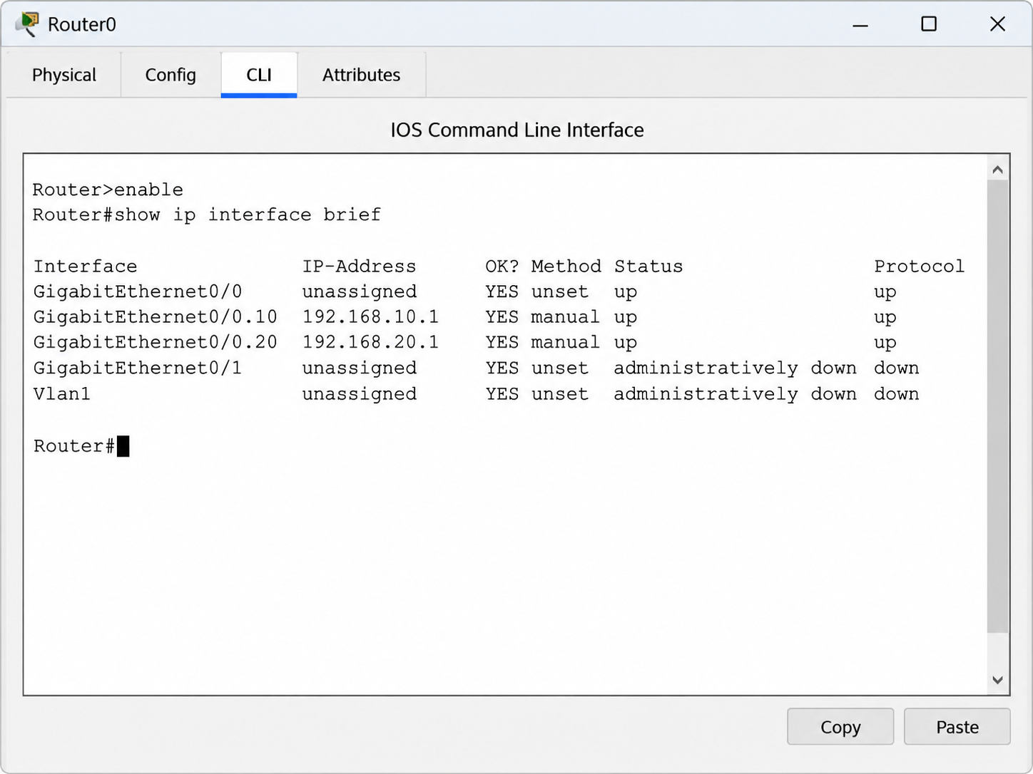
- SWITCH TRUNK STATUS
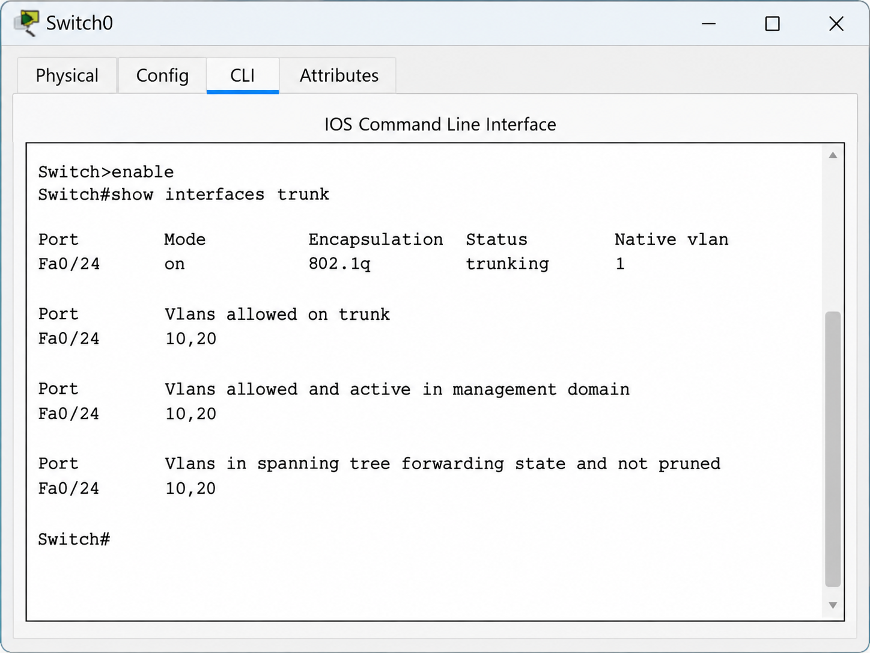

- NETWORK CONSOLE
